Ideation Phase
Brainstorm & Idea Prioritization

Date | 31 January 2025
Team ID | SWTID-2026-3373
Project Name | Import Data using Transform Maps (Spreadsheet)
Maximum Marks | 4 Marks

Step-1: Team Gathering, Collaboration and Select the Problem Statement
Problem Statement
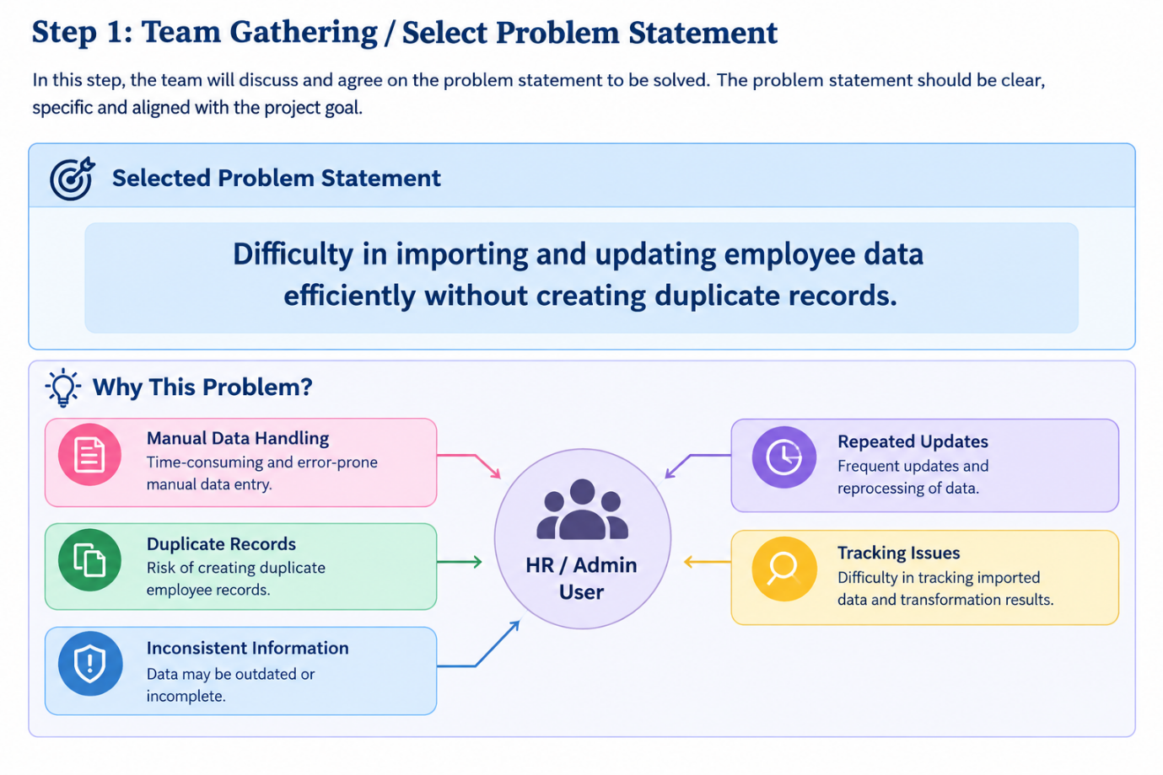

Step-2: Brainstorm, Idea Listing and Grouping

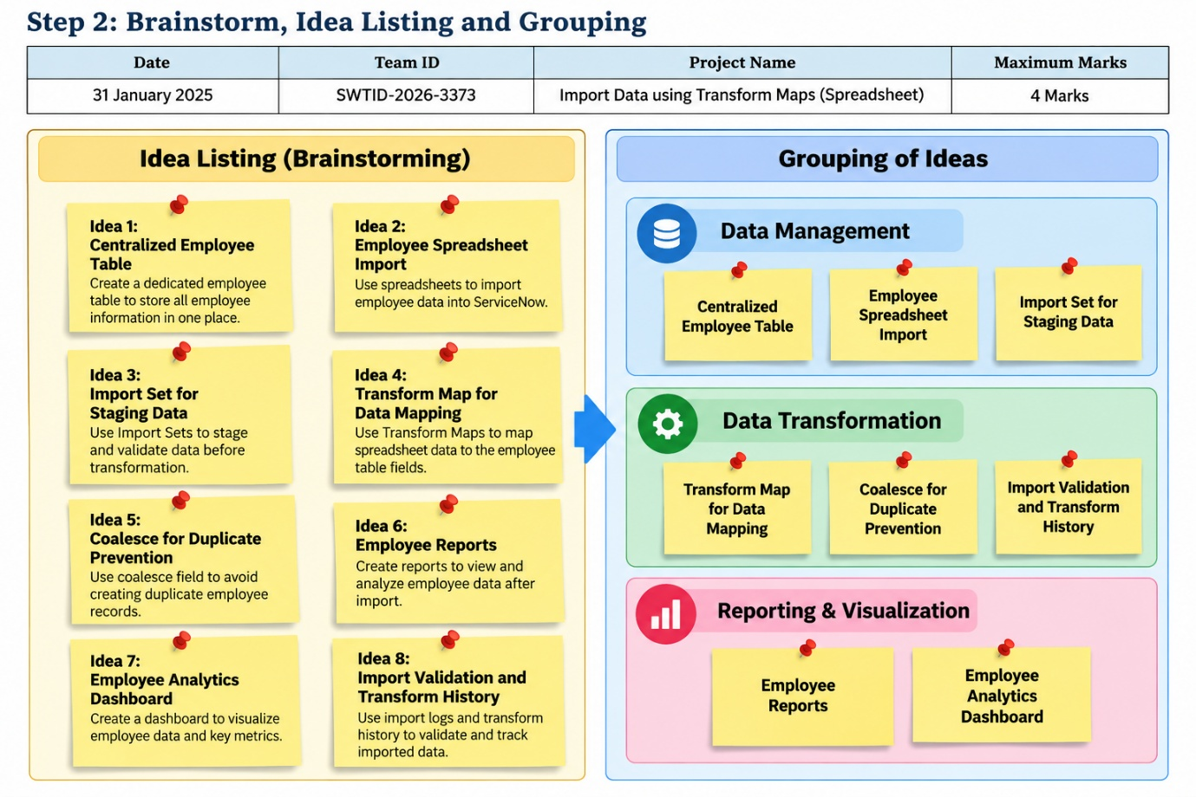

Step-3: Idea Prioritization
